Survival analysis

Objective:

What is the survival probability of a patient with primary brain tumor after 24 months of receiving therapy? Is the survival probability equal across male and female patients? Is the survival probability equal across different treatment methods?

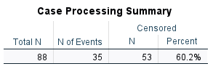

According to this table, there are 88 patients in the data set. The number of events records the number of deaths (Status = 1), so out of 88 patients, 35 died at different times of the treatment period. Censored data includes patients who survived or who left the treatment program, or who we do not have any information about what happened to them (dead or alive) once the treatment was ended. There are 53 censored patients (60.2%).

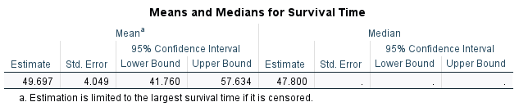

The mean survival time is 49.697 months, and the median survival time is 47.800 months. In survival analysis, the median survival time is generally reported because of the skewed nature of the data distribution.
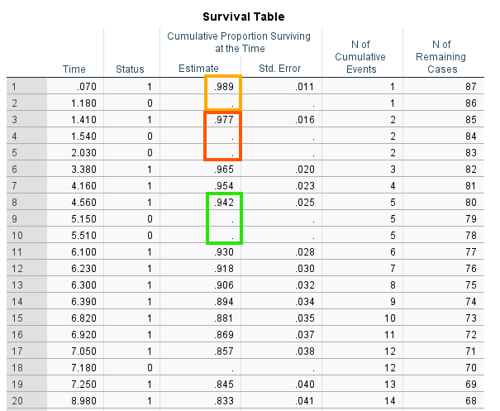
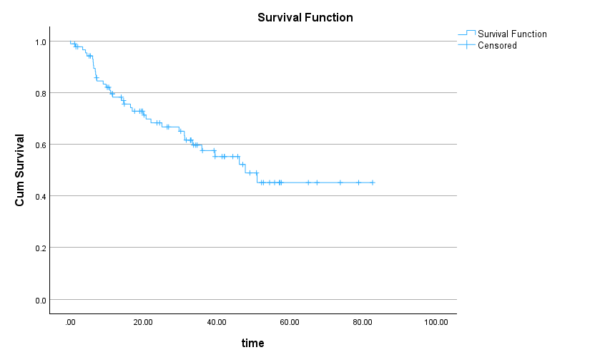

the survival probability is shown on the Y (vertical) axis and time is shown on the X (horizontal axis). If we know how long a patient has been in the treatment plan, we can estimate their survival probability. For example, for a patient in the treatment plan for 40 months, their survival probability is about 0.55 (which can also be read from the Survival Table). The plus signs on the curve indicate censored cases.

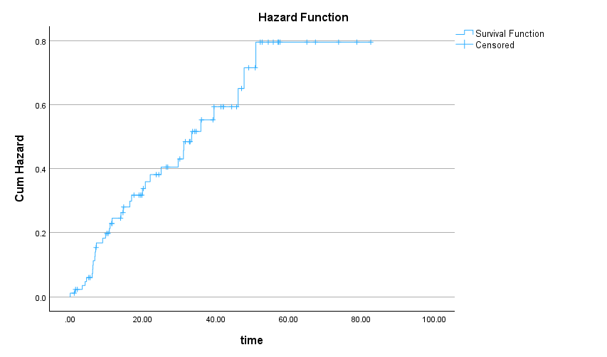

Hazard is the opposite of survival. The hazard function plot shows the probability of death at a certain time. The probability of death increases as we approach the end of the program.

Comparing Survival Probability for Female and Male Patients

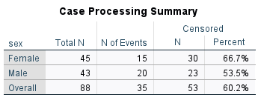

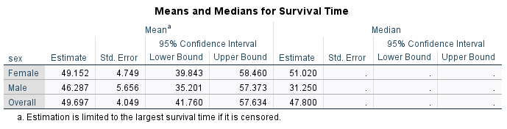

The median survival time among female patients is 51.02
months while that of male patients is 31.250 months. Is the difference statistically significant? We look at the results of the log-rank test

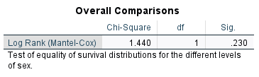

The log-rank test is based on the chi-square statistic and distribution. According to the log-rank test results, there is not a statistically significant difference between female and male patients in terms of survival probability (chi-square = 1.440, df = 1, p = 0.230). Figures 18 and 19 show the survival and hazard plots for female and male patients.

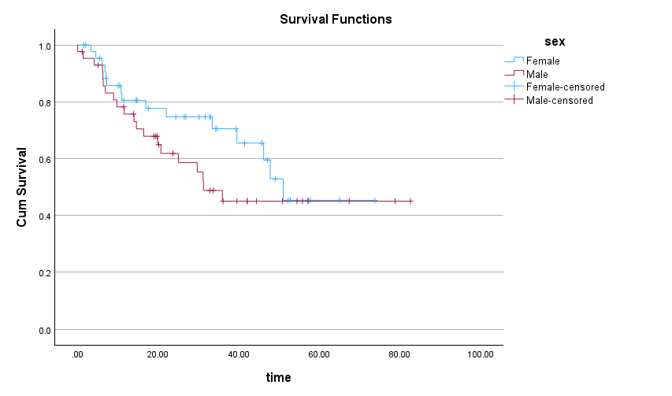

we can see that at some time intervals male patients have lower survival probability than female patients. However, the difference becomes negligible or none after about 51 months.

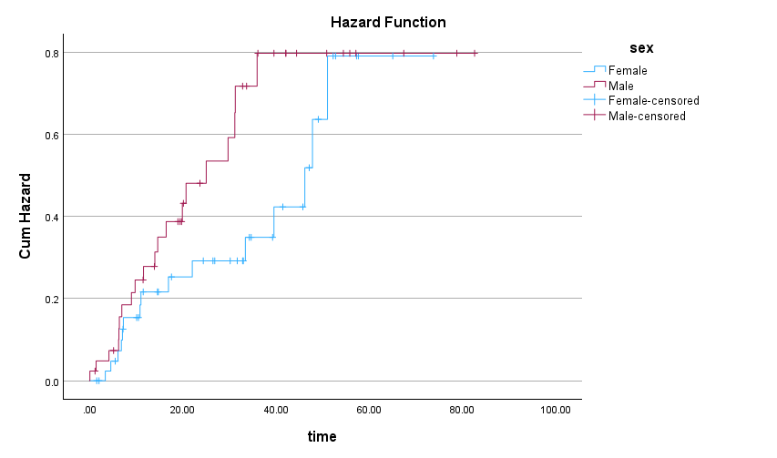

Similarly, the hazard function plot shows that the hazard difference between female and male patients becomes negligible from month 51.

If we want to know whether the survival probability is different between treatment methods, we can run the analysis again but use treatment method instead of sex as factor.

Interpretation:
A Kaplan-Meier survival analysis was conducted to compare survival distributions across female and male primary brain tumor patients. Median survival times for female and male patients were 51.02 and 31.2 months, respectively. The log-rank test indicated a non-significant difference in survival distributions, χ²(2) = 1.44, p = 0.23. Estimated median follow-up time for patients in this study was 39.25 months.

Reverse Kaplan-Meier for Estimating Median Follow-up:

To perform a Reverse Kaplan-Meier analysis in SPSS, we follow the same steps as in the Kaplan-Meier analysis, but we reverse the coding of the status variable. In our example data, we defined death as 1 and censored as 0 in Kaplan-Meier survival analysis.

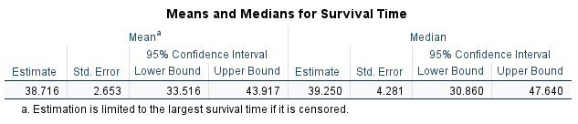

According to the output, the estimated median follow-up time for patients in this study is 39.25 months (about 3.27 years). Subject matter experts (e.g., cancer clinicians) must be consulted to evaluate the adequacy of median follow-up.

